Transformer Architecture
A Transformer model consists of two main parts:
- Encoder
- Decoder
Below Figure shows the description of Encoder and Decoder of the Transformer
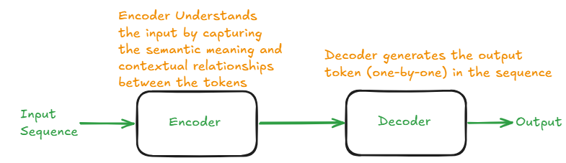

The Architecture of Encoder and Decoder of the Transformer is shown in the below Figure

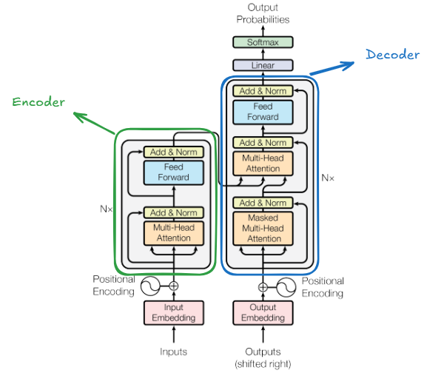

Consider an input sequence
My name is Ahsan and I love computer vision

Step 1: Tokenization
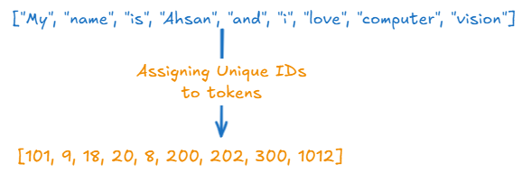

Step 2: Embeddings
Embeddings are vectors of floating-point numbers which represents the meaning of the token.
For creating Embeddings of tokens, we have to provide the Embedding dimension.
The Embedding dimensions in Transformer architecture is denoted by d_model
If d_model = 8, then the Embeddings for each token are represented as:
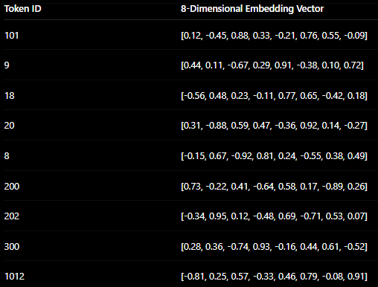
Thus, for the given input sequence (which contains 9 tokens). The output of Input Embedding Layer contains the shape (9, 8).

Note: For real world data there are large number of input token for e.g. 50,000 token and the d_model is set to 256 or 512 or 768 or 1024 etc. The output of Input Embedding Layer contains the shape (50000, 512) if dmodel=512

Step 3: Positional Encoding
In RNN, the tokens in the sequence are feed one-by-one to the input of model. So the model understand the position of every token in the input sequence.
Unlike RNN, in Transformer all the tokens are feed to the input of Encoder at the same time. So the Encoder does not understand the position of tokens in the input sequence.
Positional encoding adds information about:
- token position
- word order
- sequence structure


Below Figure represents the shapes of the output of Input Embedding Layer and the output of Positional Encoding Layer for point-wise addition are the same.
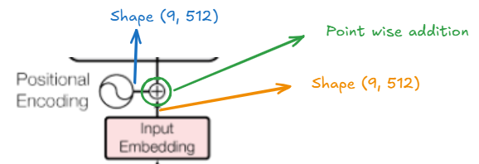
Transformer use sine and cosine functions for positional encoding
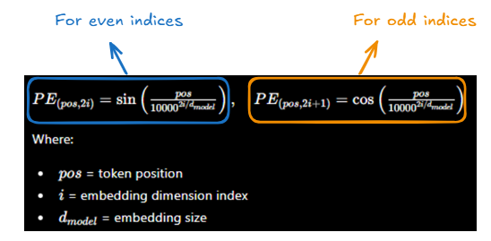

Let’s create Positional Encoding Vector for Token at position 1 i.e. “name”
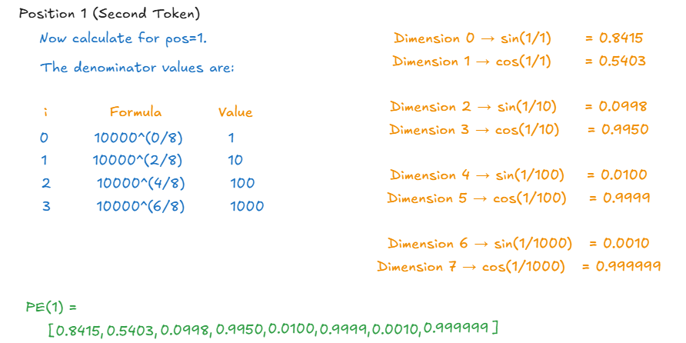

For each token, the positional encoding vectors are computed. Thus the output of Positional Encoding contains the shape (9, 8) if d_model = 8
For d_model = 512 PE output shape (9,512)
Below figure shows the Embedding and Position Encoding matrices, which are then added point-wise.
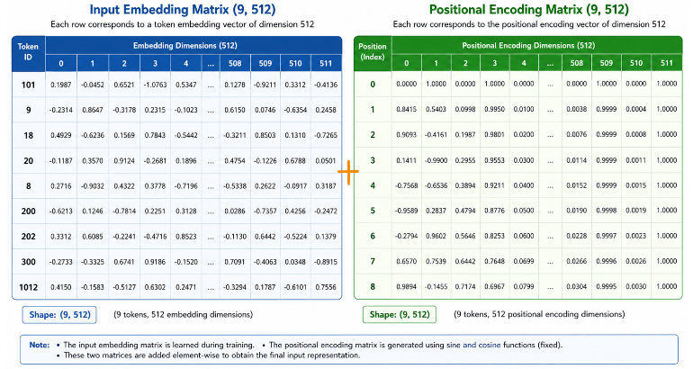

Step 3: Encoder
As I have mentioned earlier, that the encoder learns the relationship between each token in the input sequence. The relationship is learned with the help of Multi-Head Attention layer, which requires three metrices named as Query (Q), Key (K), and Value (V).
- Query (Q) --> Each token ask question "What kinds of words should I pay attention to?"
- Key (K) --> Each token says "This is what I am about"
- Value (V) --> "If you attend me, this is the information you will get"
Q, K, V are computed using weight metrices Wq, Wk and Wv
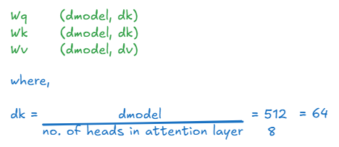

The Q, K and V is calculated for each token
For example, calculating the Q, K and V for “is” token
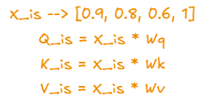
Since the input matrix X contains shape (9,512) and Wq, Wk, Wv have shape (512, dk).
So the Q, K, V have shape (9, dk)
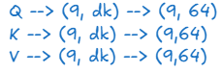

- Scaled Dot-Product Attention
The relationship between each token is calculated by Scaled Dot Product attention mechanism, which calculated the attention scores with the help of Q and K metrices.

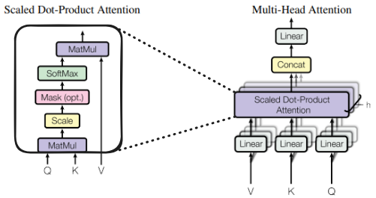
The attention score is calculated by multiplying each Query with all the Keys – with the help of MatMul Layer. The formula of calculating attention score is given below.
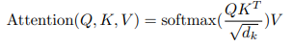
The Q.$K^{T}$ part (MatMul)

Below figure show the Query of Love token is taken dot-product with the Keys of all tokens.
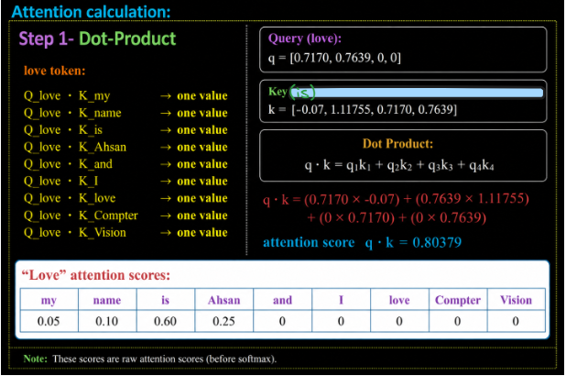

Below figure shows the resulting matrics, after Q and K are processed through MatMul Layer.
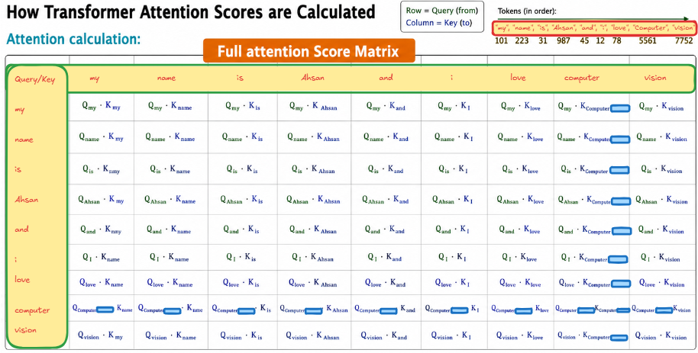

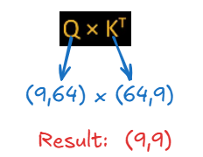

The $\frac{1}{\sqrt{d_{k}}}$ part (Scale)
Each value in the Q.$K^{T}$matrix is scaled down by dividing by $\sqrt{d_{k}}$

The Softmax part:
The softmax function converts each value in the Q.$K^{T}$ matrix to probability scores

For example, attention scores for love
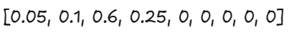

The Final MatMul Layer
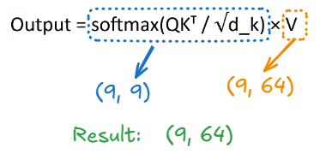

The final output matrix of Scaled Dot-Product Attention Layer
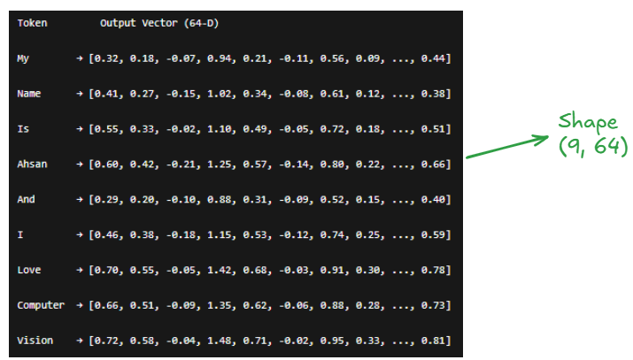

- MultiHead Attention:
In the Multi-Head Attention layer, multiple Scaled Dot-Product Attention operations run in parallel.
Each parallel attention unit is called a Head.
Different heads learn different types of relationships between tokens, such as:
- semantic relationships
- grammatical structure
- long-range dependencies
- contextual meaning
For example:
- one head may focus on subject-object relationships
- another head may focus on nearby words
- another head may capture semantic similarity
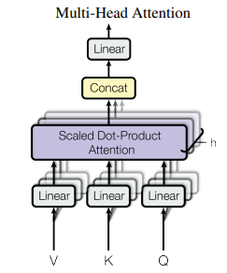

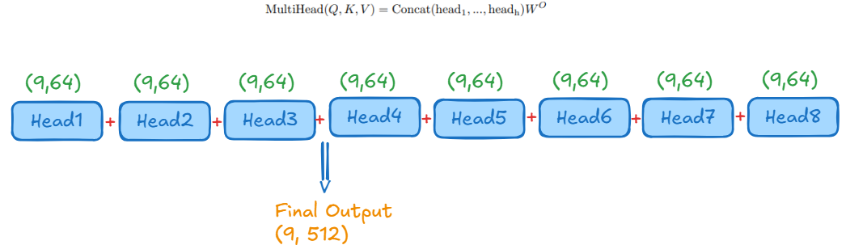

- Add and Norm Layer

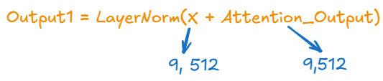
- Feed Forward Layer
The feed forward layer consists of 3 layers

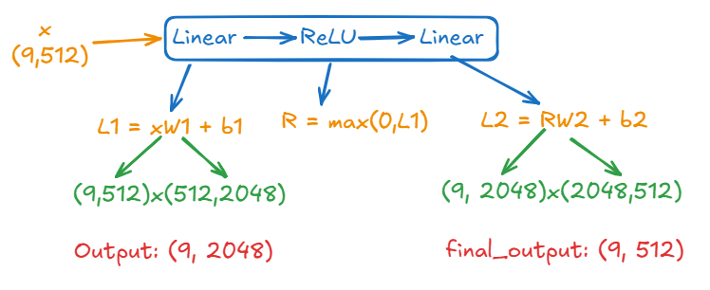

- Final add and Norm Layer

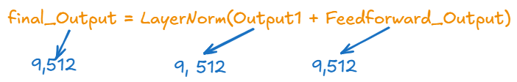

Below figure show the shapes of metrices calculated at each layer in the Encoder
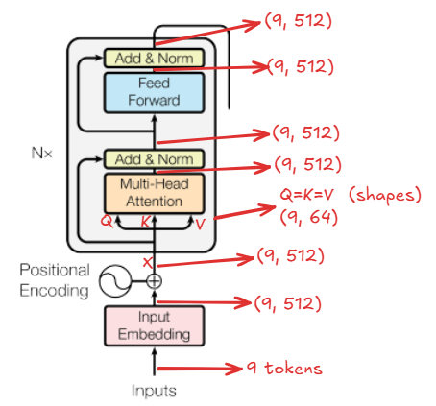

In original Transformers research paper “Attention is all you need” – there are 6 encoders
